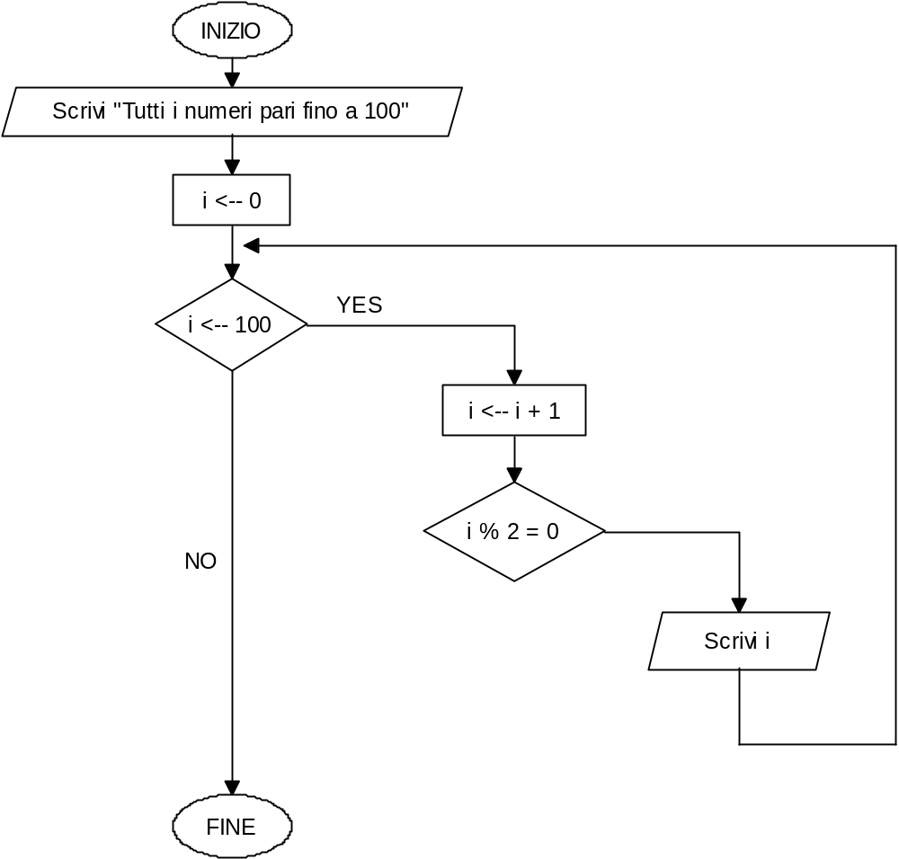

#include <iostream>
using namespace std;
int main () {
int i;
cout<<"Tutti i numeri pari fino a 100\n";
i=0;
cout<<i<<endl;
while(i<100){
i++;
if(i%2==0)
cout<<i<<endl;
}
system("pause");}

